Style Guide 1.0

## BRANDING

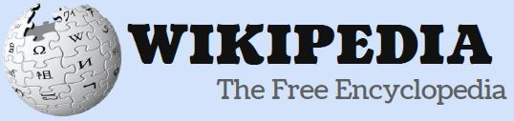



We are using these 2 logos for our website. The first logo we used in wireframes and the other one is used in prototype. The name itself speaks for the brand which is Wikipedia. Blue color is used to maintain original theme.

## COLORS

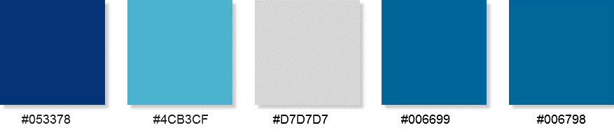

Color Palettes used in the website. Warm colors have been used since this is an information website, user spend a lot of time in reading. Hence we have used light and warm color coding which is eye-pleasing.

## TYPOGRAPHY

|  |
| --- |
| HEADER – Font Arial, Sans-Serif Size 32  SUB-HEADINGS – Font Arial, Sans-Serif Size 18, 24  General Text – Font Arial, Size 13, 16 |

Font type and size specifications implemented in our website.

## BUTTONS

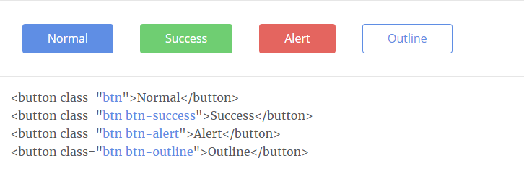

These are few of the buttons (Bootstrap based) used throughout the site.

## ICONS



These are few of the icons used throughout the site. Size has been maintained to 35 x 35 px for control based display such as down button etc.

These are few of the icons used throughout the site. Size has been maintained to 24 x 24 px for integrating within table cells/Form Fields.

## FORM ELEMENTS

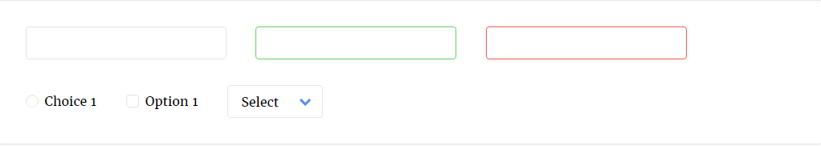

These are the form elements used in our website.